**Application Operation Manual**

**on**

**Data Management System**

**for**

**Buildings Energy Efficiency Ordinance**

**for**

**Energy Efficiency Office**

**of**

**Electrical and Mechanical Services Department (EMSD)**



By



Version: 0.1

**July 2022**

© The Government of the Hong Kong Special Administrative Region

The contents of this document remain the property of and may not be reproduced in whole or in part without the express permission of the Government of the HKSAR.

|  |  |
| --- | --- |
| **Distribution** | |
| Copy No. | Holder |
| 1 | Electrical and Mechanical Services Department (EMSD) |
| 2 | Automated Systems (HK) Limited (ASL) |

|  |  |
| --- | --- |
|  |  |
|  |  |
|  |  |

|  |  |
| --- | --- |
| Prepared By:  Christine LAM  Automated Systems (HK) Ltd.  [Project Manager] | Endorsed By:  Kenneth Fung  Electrical and Mechanical Services Department  [EE/ITD/3] |
| Date: | Date: |

|  |  |  |  |  |
| --- | --- | --- | --- | --- |
| **Amendment History** | | | | |
| Change Number | Revision Description | Section Affected | Revision Number | Date |
| 1 | Draft Version | All | 0.1 | 06/07/2022 |
|  |  |  |  |  |
|  |  |  |  |  |

**Table of Contents**

1. Purpose 4

2. Scope 5

3. Reference 6

4. Definitions and Conventions 6

4.1 Definitions 6

4.2 Conventions 6

5. System Description 7

5.1 System Overview 7

5.1.1 BEEO Web Application 7

5.1.2 Mobile Inspection 7

5.2 Job Description 8

5.2.1 BJ_GenBringUpAndReminder 8

5.2.2 BJ_GenReport 10

5.2.3 BJ_Checklist_MobileList 10

5.2.4 BJ_LetterAction 11

5.2.5 BJ_SendElicenceEmail 11

5.2.6 BJ_SendReminder 11

5.2.7 MS SQL jobs 11

5.2.8 MS SQL Report Subscriptions 11

5.3 System Flow 12

5.4 Job Run Flow 13

5.4.1 BJ_GenBringUpAndReminder 13

5.4.2 BJ_GenReport 13

5.4.3 BJ_Checklist_MobileList 13

5.4.4 BJ_LetterAction 14

5.4.5 BJ_SendElicenceEmail 14

5.4.6 BJ_SendReminder 14

5.4.7 MS SQL jobs 14

5.4.8 MS SQL Report Subscriptions 15

5.5 Summary of program description 16

6. System output reports 17

7. System Media Inputs and Outputs 20

8. Operations description 21

8.1 On-line Schedule 21

8.2 Backup Schedule 21

8.3 Ad-hoc Schedule 21

9. Run job specification 22

9.1 BJ_GenBringUpAndReminder 22

9.2 BJ_GenReport 22

9.3 BJ_Checklist_MobileList 23

9.4 BJ_LetterAction 23

9.5 BJ_SendElicenceEmail 23

9.6 BJ_SendReminder 24

9.7 MS SQL jobs 24

9.8 MS SQL Report Subscriptions 25

10. Error handling 26

10.1 Critical Errors Handling 26

10.2 Non-critical Errors Handling 26

10.3 Contact Points 26

# Purpose

The purpose of this manual is to:

provide relevant information on the various functions of Data Management System for Buildings Energy Efficiency Ordinance (DMS-BEEO)

serve as a guideline for the operating staff on the application implemented; and

document the instructions of all the work to be performed by the operating staff in running the application system, and the operation procedures for job preparation and restart.

# Scope

This document defines the operation procedure for (DMS-BEEO). It should be reference for all operation staff involved in (DMS-BEEO) operation.

# Reference

Documentation Standards for Implementation Phase (S8)

# Definitions and Conventions

## Definitions

|  |  |
| --- | --- |
| DMS | Data Management System |
| DB | MS SQL Database |
| Rptserv | MS SQL Report Server |
| LN | Lotus Notes |
| EA | Energy Audit |
| FOC | Form of Compliance |
| COCR | Certificate of Compliance Registration |
| INSP | Inspection |
| REA | Registered Energy Auditor |

## Conventions

NIL

# System Description

## System Overview

The DMS consists of the following module, jobs or applications:

* BEEO Web Application
* Mobile Inspection
* BJ_GenBringUpAndReminder
* BJ_GenReport
* BJ_Checklist_MobileList
* BJ_LetterAction
* BJ_SendElicenceEmail
* BJ_SendReminder
* MS SQL jobs
* MS SQL Report Subscription
  + 1. BEEO Web Application

This module is a web application located on IIS. It is the main core part of the system which manages the information of assignment, buildings, referrals and summons, the submission for EA, FOC, COCR, REA and Inspection. It also includes generation of letters, checklist, improvement notices and reports. It manages the workflow of the submission, sending reminders and bring ups to user. In addition, it facilitates batch generation of letters, random selection of buildings. For more details, please refer to “*DMS-BEEO User Guide.doc”.*

The application is located in application server *c$\csudemo*

* + 1. Mobile Inspection

To be completed by Amy

## Job Description

* + 1. BJ_GenBringUpAndReminder

This job generates report reminders, case specified reminders and user-defined (UD) reminders periodically. It also generate the base list for process “random selection of building list”

The job is an exe program located in application server c$\BJ_GenBringUpAndReminder\bin\Release\ BJ_GenBringUpAndReminder.exe

The configuration of bring up is stored in table *tbl_BringUp_config* in the database.

Case specified reminders which generated when required situation occur.

The job check the situation once daily.

|  |  |  |
| --- | --- | --- |
| **Bring Up Type ID** | **Description** | **Enable** |
| BG-COCR-13 | buildings with stage two declaration received, COCR not yet issued (or not yet refused) and the deadlines (i.e. 3 months after the day on which the declaration is received) have already expired | No |
| BG-COCR-14 | buildings with stage two declaration received, COCR not yet issued (or not yet refused) and the deadlines are to be expired in N7 month(s) (where N7 should be configurable) | No |
| BG-COCR-15 | (Send Once) buildings with stage two declaration received, COCR not yet issued (or not yet refused) and the deadlines are to be expired in 1 month | Yes |
| BG-COCR-16 | (Send Once) buildings with stage two declaration received, COCR not yet issued (or not yet refused) and the deadlines are to be expired in 2 weeks | Yes |
| BG-COCR-17 | (Send Once) Building with the anticipated occupation approval date due for preparation of stage 2 submission | Yes |
| BG-EA-4 | buildings with energy audit forms already expired but still without valid energy audit forms in force | No |
| BG-EA-5 | buildings with energy audit forms which are currently in force are to be expired in N2 month(s) (where N2 should be configurable) | No |
| BG-INSP-1 | buildings to be inspected in N9 month(s) | No |

Report reminders consist of monthly and weekly type. For monthly type, when the day configured on the month come, this kind of reminder will be generated. For weekly type, when the day (1-7) configured in a week come, the reminder and the report (excel format) will be generated

|  |  |  |
| --- | --- | --- |
| **Bring Up Type ID** | **Description** | **Enable** |
| RPT-COCR-13 | Weekly report of buildings with stage two declaration received, COCR not yet issued (or not yet refused) and the deadlines (i.e. 3 months after the day on which the declaration is received) have already expired | Yes |
| RPT-COCR-14 | Monthly report of buildings with stage two declaration received, COCR not yet issued (or not yet refused) and the deadlines are to be expired in N7 month(s) | Yes |
| RPT-COCR-32 | Monthly report of Received COCR Stage One Declaration which are not closed 6 months after received | Yes |
| RPT-COCR-33 | Monthly report of Received COCR Stage Two Declaration which are not closed 6 months after received | Yes |
| RPT-EA-2 | Weekly report of buildings without energy audit form received but first energy audit deadlines have already expired (i.e. 10 years after the building is first issued with a Certificate of Compliance Registration or pursuant to schedule 5 of the Ordinance) | Yes |
| RPT-EA-3 | Monthly report of buildings without energy audit form received but first energy audit deadlines will be expired in N1 month(s) | Yes |
| RPT-EA-30 | Monthly report of Received Energy Audit Form which are not closed 6 months after received | Yes |
| RPT-EA-4 | Weekly report of buildings with energy audit forms already expired but still without valid energy audit forms in force | Yes |
| RPT-EA-5 | Monthly report of buildings with energy audit forms which are currently in force are to be expired in N2 month(s) | Yes |
| RPT-FOC-31 | Monthly report of Received FOC which are not closed 6 months after received | Yes |
| RPT-INSP-16 | Weekly report of buildings to be inspected in N9 month(s) | Yes |

User-defined (UD) reminders – the job checks for effective UD bring up and generate the corresponding reminder.

|  |  |  |
| --- | --- | --- |
| **Bring Up Type ID** | **Description** | **Enable** |
| UD | User Defined reminder | Yes |

* + 1. BJ_GenReport

This job runs on the end of weekdays each week to generates reports and excel file. The job will email them to target users. The excel file was used for import to WBRS manually.

"BEEO Register & List.xls" – for WBRS import.

"BEEO Statistics Report.xls"

The job is an exe program located in application server c$\BJ_GenReport\bin\Release\ BJ_GenReport.exe

* + 1. BJ_Checklist_MobileList

To be completed by Amy

* + 1. BJ_LetterAction

To be completed by Amy

* + 1. BJ_SendElicenceEmail

This job creates E-licence and send email with E-licence as attachment to the applicant and inform related parties after “Payment Received Date” + N days (Configurable).

The job is an exe program located in application server c$\BJ_SendElicenceEmail \bin\Release\ BJ_SendElicenceEmail.exe

The schedule of job is TBC.

* + 1. BJ_SendReminder

This job creates emails for the reminders generated and sends them to target user through LN.

The job is an exe program located in application server c$\BJ_SendReminder\bin\Release\ BJ_SendReminder.exe

* + 1. MS SQL jobs

The following jobs are stored in mssql server and are run by mssql agents.

* *backupbeeo.Subplan_1*

This job backup database

* *HandlingPendingBringUp*

This job set pending bring up to effective state if bring up time reach.

* *Letter_Advisory_letter*

To be completed by Amy

* *UPDATEBATCHSTATUS*

This job update batch job (batch generation of letter) status

* + 1. MS SQL Report Subscriptions

To be completed by Amy

## System Flow

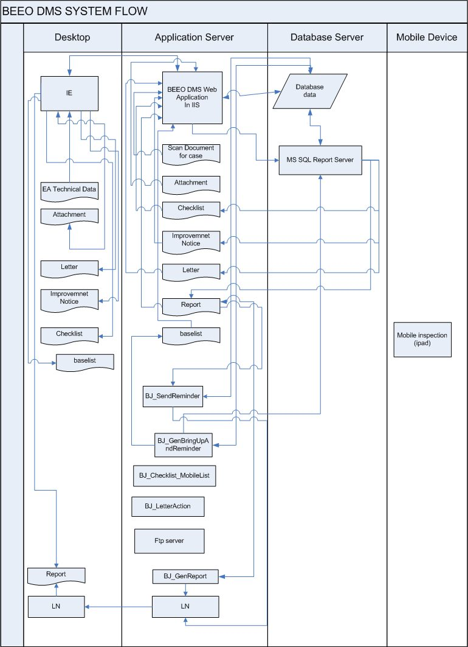

the BJ_Checklist_MobileList, BJ_LetterAction,ftp and Mobile Inspection on this diagram are not complete. Amy please modify beeo.vsd file and send me back

## Job Run Flow

* + 1. BJ_GenBringUpAndReminder

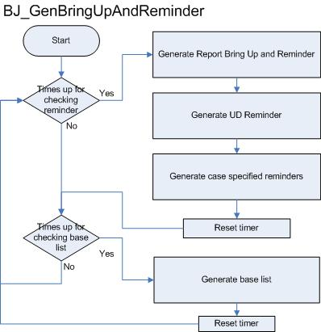

* + 1. BJ_GenReport

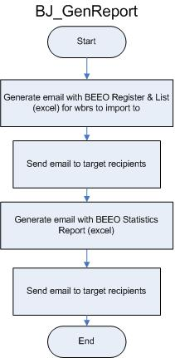

* + 1. BJ_Checklist_MobileList

To be completed by Amy

* + 1. BJ_LetterAction

To be completed by Amy

* + 1. BJ_SendElicenceEmail

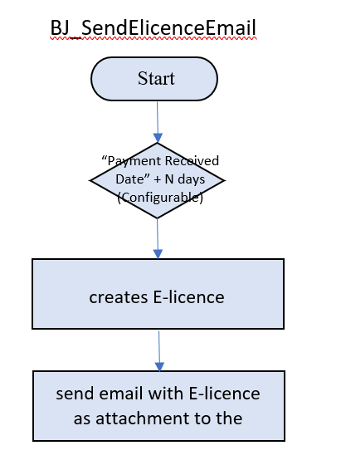

* + 1. BJ_SendReminder

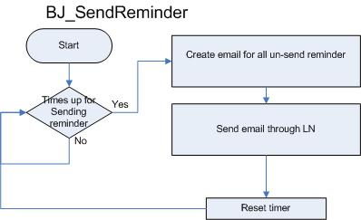

* + 1. MS SQL jobs

The following jobs are run by mssql agent.

* *backupbeeo.Subplan_1*

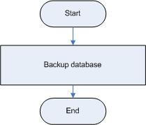

* *HandlingPendingBringUp*

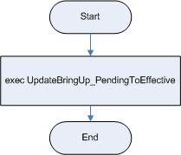

* *Letter_Advisory_letter*

To be completed by Amy

* *UPDATEBATCHSTATUS*

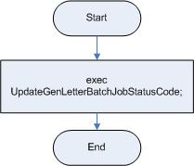

* + 1. MS SQL Report Subscriptions

To be completed by Amy

## Summary of program description

|  |  |
| --- | --- |
| **Program/Job** | **Description** |
| BEEO Web Application | the main core part of the system which manages the information of assignment, buildings, referrals and summons, the submission for EA, FOC, COCR, REA and Inspection. It also includes generation of letters, checklist, improvement notices and reports. It manages the workflow of the submission, sending reminders and bring ups to user. In addition, it facilitates batch generation of letters, random selection of buildings |
| Mobile Inspection |  |
| BJ_GenBringUpAndReminder | generates report reminders, case specified reminders and user-defined (UD) reminders periodically. It also generate the base list for process “random selection of building list” |
| BJ_GenReport | generates reports and excel file:  *"BEEO Register & List.xls" –* for WBRS import.  *"BEEO Statistics Report.xls"* |
| BJ_Checklist_MobileList |  |
| BJ_LetterAction |  |
| BJ_SendElicenceEmail | After “Payment Received Date” + N days (Configurable), send email with E-licence as attachment to the applicant and inform related parties |
| BJ_SendReminder | creates emails for the reminders generated and sends them to target user through LN |
| backupbeeo.Subplan_1 | backup database |
| HandlingPendingBringUp | set pending bring up to effective state if bring up time reach |
| Letter_Advisory_letter |  |
| UPDATEBATCHSTATUS | update batch job (batch generation of letter) status |
|  |  |
|  |  |
|  |  |

To be completed by Amy

# System output reports

|  |  |  |  |
| --- | --- | --- | --- |
| **Report type ID** | **Category** | **Description** | **is Online Report** |
| 1 | REA | Statistics and Summary | Yes |
| 2 | EA | Weekly report of buildings without energy audit form received but first energy audit deadlines have already expired (i.e. 10 years after the building is first issued with a Certificate of Compliance Registration or pursuant to schedule 5 of the Ordinance) |  |
| 3 | EA | Monthly report of buildings without energy audit form received but first energy audit deadlines will be expired in N1 month(s) |  |
| 4 | EA | Weekly report of buildings with energy audit forms already expired but still without valid energy audit forms in force |  |
| 5 | EA | Monthly report of buildings with energy audit forms which are currently in force are to be expired in N2 month(s) |  |
| 6 | FOC | Weekly report of completed major retrofitting works without FOC received but the (anticipated) deadlines (i.e. 2 months after the anticipated/actual completion date of major retrofitting works) have already expired |  |
| 7 | FOC | Monthly report of completed major retrofitting works without FOC received and the (anticipated) deadlines will be expired in N3 month(s) |  |
| 8 | FOC | Monthly report of major retrofitting works without FOC received and the works are anticipated to be completed in N4 month(s) |  |
| 9 | COCR | Weekly report of buildings without stage one declaration received but the deadlines (i.e. 2 months after the day on which the consent to the commencement of building works for the superstructure construction of the building is given) have already expired |  |
| 10 | COCR | Monthly report of buildings without stage one declaration received but the deadlines are to be expired in N5 month(s) |  |
| 11 | COCR | Weekly report of buildings without stage two declaration received but the (anticipated) deadlines (i.e. 4 months after the day on which the (anticipated) occupation approval is issued in respect of the building) have already expired |  |
| 12 | COCR | Monthly report of buildings without stage two declaration received but the (anticipated) deadlines are to be expired in N6 month(s) |  |
| 13 | COCR | Weekly report of buildings with stage two declaration received, COCR not yet issued (or not yet refused) and the deadlines (i.e. 3 months after the day on which the declaration is received) have already expired |  |
| 14 | COCR | Monthly report of buildings with stage two declaration received, COCR not yet issued (or not yet refused) and the deadlines are to be expired in N7 month(s) |  |
| 15 | COCR | Weekly report of buildings with COCR already expired but not yet renewed |  |
| 16 | INSP | Weekly report of buildings to be inspected in N9 month(s) |  |
| 17 | IN | Weekly report of buildings with issued IN not yet rectified and the deadlines for rectification have already expired |  |
| 18 | IN | Monthly report of buildings with issued IN not yet rectified and the deadlines for rectification are to be expired in N10 month(s) |  |
| 19 | REA | List of REA Register | Yes |
| 20 | REA | List of Issued / Renewed REA Certificate per Reporting Period | Yes |
| 21 | REA | List of REA to be expired within 12 months / 6 months / 3 months | Yes |
| 22 | INSP | List of Buildings being inspected in past 12 months / 6 months / 3 months | Yes |
| 23 | INSP | List of Buildings to be inspected in next 12 months / 6 months / 3 months | Yes |
| 24 | COCR | List of Received COCR Stage One Declaration per Reporting Period | Yes |
| 25 | COCR | List of Received COCR Stage Two Declaration per Reporting Period | Yes |
| 26 | COCR | List of Received COCR Renewal per Reporting Period | Yes |
| 27 | EA | List of Received Applications for EA Exemptions per Reporting Period | Yes |
| 29 | FOC | List of Received FOC per Reporting Period | Yes |
| 28 | EA | List of Received Energy Audit Form per Reporting Period | Yes |
| 30 | EA | List of Received Energy Audit Form which are not closed 6 months after received |  |
| 31 | FOC | List of Received FOC which are not closed 6 months after received |  |
| 32 | COCR | List of Received COCR Stage One Declaration which are not closed 6 months after received |  |
| 33 | COCR | List of Received COCR Stage Two Declaration which are not closed 6 months after received |  |

# System Media Inputs and Outputs

Please refer to COPM document.

# Operations description

This section should describe the Operation schedule and service hours of the Application System.

## On-line Schedule

This system provides online service in 7 x 24 basis

## Backup Schedule

Please refer to COPM document

## Ad-hoc Schedule

Nil.

# Run job specification

## BJ_GenBringUpAndReminder

**Function**

This job generates report reminders, case specified reminders and user-defined (UD) reminders periodically. It also generate the base list for process “random selection of building list”

**Estimate Run Time**: run continuously

**Parameters:**

In application server c$\BJ_GenBringUpAndReminder\bin\Release\ *BJ_GenBringUpAndReminder.exe.config*

|  |  |  |
| --- | --- | --- |
| **Variable Name** | **Description** | **mins** |
| checkingIntevalinMins | The time interval for checking reminders to be generated | 30 |
| checkingGenBaseListExcelIntevalinMins | The time interval for checking base list to be generated | 20 |

**Requirement/Limitation:** Database started

**Program Schedule**: run continuously

**Restart Procedure**: In case of system error, simply restart the program.

**Output Listings**: Bringups, reminders, baselist.

## BJ_GenReport

**Function**

This job runs on the end of weekdays each week to generates reports and excel file. The job will email them to target users. The excel file was used for import to WBRS manually.

**Estimate Run Time**: 10 mins – 20 mins

**Parameters:**

In application server *c$\BJ_GenReport\bin\Release* *BJ_GenReport.exe.config*

|  |  |
| --- | --- |
| **Variable Name** | **Description** |
| mailaddr | Recipants |

**Requirement/Limitation:** Database and Lotus Notes client need to be started.

**Program Schedule**: run on weekday end

**Restart Procedure**: In case of system error, simply restart the program.

**Output Listings**:

Email with "BEEO Register & List.xls" – for WBRS import.

Email with "BEEO Statistics Report.xls"

The above excel file is generated in *c:\beeo\bj_GenReport*

## BJ_Checklist_MobileList

To be completed by Amy

## BJ_LetterAction

To be completed by Amy

## BJ_SendElicenceEmail

**Function**

This job creates E-licence and send email with E-licence as attachment to the applicant and inform related parties after “Payment Received Date” + N days (Configurable).

**Estimate Run Time**: run continuously

**Parameters:**

In application server c$\BJ_SendElicenceEmail \bin\Release\ *BJ_*SendElicenceEmail*.exe.config*

|  |  |
| --- | --- |
| **Variable Name** | **Description** |
| Id | E-licence ID |
| Lek | LEK |
| LicenceType | Licence Type |
| ElicencePdf | The PDF file of the E-licence |
| RegNo | REA Registration Number of Applicant |
| Email | Email Address of Applicant |

**Requirement/Limitation:** Database started

**Program Schedule**: run continuously

**Restart Procedure**: In case of system error, simply restart the program.

**Output Listings**: Email with E-licence attachment

## BJ_SendReminder

This job creates emails for the reminders generated and sends them to target user through LN.

The job is an exe program located in application server c$\BJ_SendReminder\bin\Release\ BJ_SendReminder.exe

**Function**

This job creates emails for the reminders generated and sends them to target user through LN.

**Estimate Run Time**: run continously

**Parameters:**

In application server *c$\BJ_SendReminder\bin\Release\ BJ_SendReminder.exe.config*

|  |  |  |
| --- | --- | --- |
| **Variable Name** | **Description** | **mins** |
| reminderIntevalinMins | The time interval for sending reminders | 1 |

**Requirement/Limitation:** Database and Lotus Notes client need to be started.

**Program Schedule**: run continuously

**Restart Procedure**: In case of system error, simply restart the program.

**Output Listings**:Email reminders

## MS SQL jobs

* *backupbeeo.Subplan_1*

**Function**: backup database

**Estimate Run Time:** 1-10 mins (depends on database size)

**Parameters**: Nil

**Requirement/Limitation:**mssql server and mssql agents started

**Program Schedule:** run at 11:00 pm daily

**Restart Procedure**: In case of system error, simply restart the job

**Output Listings**: backup database file

(in c$\beeodbbackup\BEEOMDS on database server.)

* *HandlingPendingBringUp*

**Function**:

Set pending bring up to effective state if bring up time reach

**Estimate Run Time:** depends on database size

**Parameters**: Nil

**Requirement/Limitation:**mssql server and mssql agents started

**Program Schedule:** run every 15 mins

**Restart Procedure**: In case of system error, simply restart the job

**Output Listings**: Nil

* *Letter_Advisory_letter*

To be completed by Amy

* *UPDATEBATCHSTATUS*

**Function**:

Update batch job (batch generation of letter) status

**Estimate Run Time:** depends on database size

**Parameters**: Nil

**Requirement/Limitation:**mssql server and mssql agents started

**Program Schedule:** run every 24 mins

**Restart Procedure**: In case of system error, simply restart the job

**Output Listings**: Nil

## MS SQL Report Subscriptions

To be completed by Amy

# Error handling

Error happens in the BEEO-DMS operation is classified as critical and non-critical. Unless otherwise specified in the Section 9: Run Job Specification that it will affect the on-line service on the next day or immediate on-line service, all jobs are considered non-critical.

## Critical Errors Handling

When there is an abnormal end in running job, users should refer to the Section 9: Run Job Specification, and follow the procedures to prepare for restart or recovery.

If a critical job fails to recover, users should contact in-house Support Staff of the Application for advice. Also, to record all information about job failure, such as time and date, error message code and content, relevant data and actions performed for further investigation.

## Non-critical Errors Handling

All jobs are considered non-critical unless otherwise specified. All non-critical jobs should be restart/recover using the restart/recovery procedures in the corresponding sub-section of the Section 9: Run Job Specification. If the procedures fail on job restart/recovery, users should contact in-house Support Staff to follow up the issues.

## Contact Points

|  |  |
| --- | --- |
| User Support | Office Hours |
| ITMU | 2808 3929 |
|  |  |

- End of Document -